**YASH SARANG**

**D6AD**

**47**

**DLCOA / Experiment 9**

------------------------------------------------------------------------------------------------------------------------

AIM: To write a C program for implementation of Non- Restoring Division.

------------------------------------------------------------------------------------------------------------------------

SOFTWARE: Turbo C IDE

------------------------------------------------------------------------------------------------------------------------

THEORY: In non-restoring division method, the dividend is NOT restored after the subtraction operation. Instead, the logic or flow of the code is as follows:

If the current remainder is positive then,

Q. = 1;

Next operation will be shift and subtract;

Else if remainder is negative then,

Q. = 0;

Next operation will be shift and add;

**FLOWCHART:**

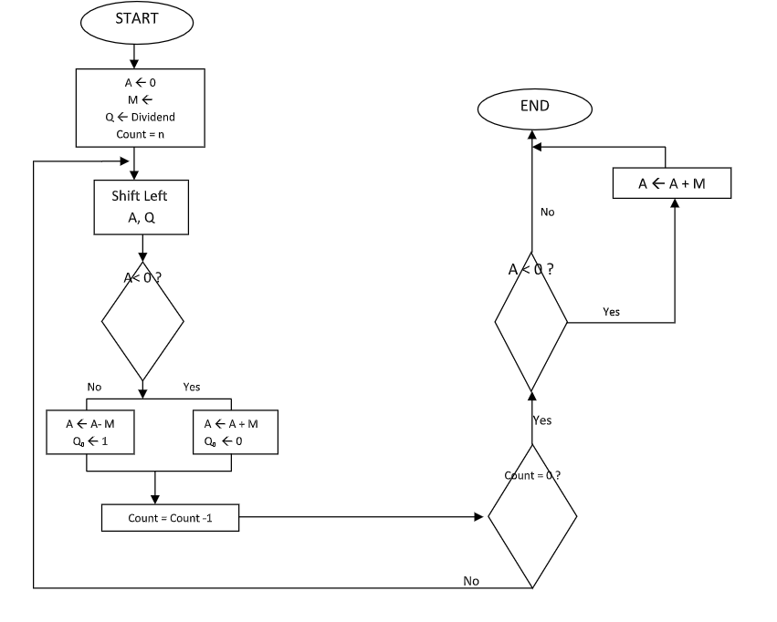

------------------------------------------------------------------------------------------------------------------------

**CODE:**

#include<stdio.h>

#include<stdlib.h>

int acum[100] = {0};

void add(int acum[], int b[], int n);

int q[100], b[100], l;

int main()

{

int x, y;

printf("Enter the Number : ");

scanf("%d%d", & x, & y);

int i = 0;

while (x > 0 || y > 0) {

if (x > 0)

{

q[i] = x % 2;

x = x / 2;

}

else

{

q[i] = 0;

}

if (y > 0)

{

b[i] = y % 2;

y = y / 2;

}

else

{

b[i] = 0;

}

i++;

}

int n = i;

int bc[50];

printf("\n");

for (i = 0; i < n; i++)

{

if (b[i] == 0)

{

bc[i] = 1;

}

else

{

bc[i] = 0;

}

}

bc[n] = 1;

for (i = 0; i <= n; i++)

{

if (bc[i] == 0)

{

bc[i] = 1;

i = n + 2;

}

else

{

bc[i] = 0;

}

}

b[n] = 0;

int j;

for (i = n; i != 0; i--)

{

if (acum[n] == 0)

{

for (j = n; j > 0; j--)

{

acum[j] = acum[j - 1];

}

acum[0] = q[n - 1];

for (j = n - 1; j > 0; j--)

{

q[j] = q[j - 1];

}

add(acum, bc, n + 1);

}

else

{

for (j = n; j > 0; j--)

{

acum[j] = acum[j - 1];

}

acum[0] = q[n - 1];

for (j = n - 1; j > 0; j--)

{

q[j] = q[j - 1];

}

add(acum, b, n + 1);

}

if (acum[n] == 1)

{

q[0] = 0;

}

else

{

q[0] = 1;

}

}

if (acum[n] == 1)

{

add(acum, b, n + 1);

}

printf("\nQuoient : ");

for (l = n - 1; l >= 0; l--)

{

printf("%d", q[l]);

}

printf("\nRemainder : ");

for (l = n; l >= 0; l--) {

printf("%d", acum[l]);

}

return 0;

}

void add(int acum[], int bo[], int n) {

int i = 0, temp = 0, sum = 0;

for (i = 0; i < n; i++) {

sum = 0;

sum = acum[i] + bo[i] + temp;

if (sum == 0) {

acum[i] = 0;

temp = 0;

} else if (sum == 2) {

acum[i] = 0;

temp = 1;

} else if (sum == 1) {

acum[i] = 1;

temp = 0;

} else if (sum == 3) {

acum[i] = 1;

temp = 1;

}

}

}

------------------------------------------------------------------------------------------------------------------------



